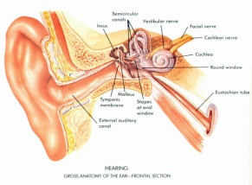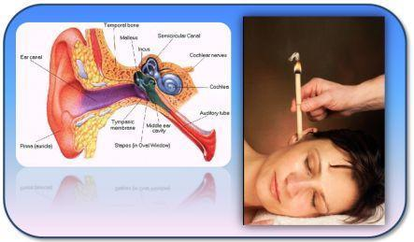

Ear Candling

**This treatment is now recognized as beneficial to those with sinus conditions, tinnitus, labyrinthitis, allergic rhinitis, headaches, migraine, excessive ear wax, and other conditions. It is also highly recommended for frequent fliers and divers.**

**How Do Ear Candles Work?**

**The candle will be lit at one end and the other end placed in the ear. The heat and movement from the flame cause a gentle vibration and the heat from the candle starts to soften any wax. It works like a chimney with a suction effect. Vapors will circulate within the ear and draw impurities out of it. Some of these can take up to 48 hours to be drawn out, but generally can be seen on the ear or in the candle remnants immediately after treatment.**

**Warning: Do not use this treatment for acute infection or within 48 hours of completing antibiotic cycle. Do not use if you have a perforated ear drum, tympanotomy, tube implants, any inflammations of the ear, skin diseases or rash in or around the ear.**